

**STATE OF CONNECTICUT**

PUBLIC UTILITIES REGULATORY AUTHORITY

June 26, 2020

In reply, please refer to:

Docket No. 20-01-01:EL:PMC

Joaquina Borges King, Esq.

Senior Counsel

The Connecticut Light and Power Company

P.O. Box 270

Hartford, CT 06141-0270

Re: Docket No. 20-01-01 – Administrative Proceeding to Review The Connecticut Light and Power Company’s Standard Service and Supplier of Last Resort Service 2020 Procurement Results and Rates

Docket No. 20-03-01 – PURA Annual Review of the Rate Adjustment Mechanisms of The Connecticut Light and Power Company

Dear Ms. Borges King:

In the filings dated May 1, 2020, and June 19, 2020, in Docket No. 20-01-01, pursuant to §§ 16-19b and 16-244c of the General Statutes of Connecticut, The Connecticut Light and Power Company d/b/a Eversource (CL&P or Company) requested that the Public Utilities Regulatory Authority (Authority or PURA) approve changes to the Revenue Decoupling Mechanism (RDM) charge, Transmission Adjustment Clause (TAC) charge, Non‑Bypassable Federally-Mandated Congestion Charge (NBFMCC) charge, and Electric System Improvements Tracker (ESI) charge, to become effective on July 1, 2020. Additionally, the Company submitted a TAC update filing on June 12, 2020, in Docket No. 20-03-01.

The Company proposed no changes to the previously approved Conservation Adjustment Mechanism charge, Competitive Transition Assessment (CTA) charge, System Benefits charge, and Renewable Energy charge. CL&P Correspondence dated June 19, 2020, in Docket No. 20-01-01, Application, p. 7.

CL&P currently recovers the total cost of providing electric service to its customers through individual unbundled charges. Effective July 1, 2020, the currently approved rate for many of these billing components will change. The instant proceeding was established to provide a docket where changes to all individual rate components can be proposed for an upcoming period. Changes to certain individual components proposed in CL&P’s filings are discussed below.[1]

**1. Revenue Decoupling Mechanism Charge**

On June 8, 2020, CL&P filed a proposed increase in the RDM rate based on actual recoveries compared to the allowed revenue requirement in the CL&P Rate Decision. This rate will increase from the current -0.011¢/kWh to 0.182¢/kWh on July 1, 2020. CL&P Correspondence dated June 19, 2020, in Docket No. 20-01-01, Application, pp. 6 and 7.

The Company’s proposed RDM rate was approved by the Authority on June 16, 2020. See PURA Rulings to Motion No. 52 in Docket No. 17-10-46.

**2. Transmission Charge**

CL&P proposed to increase its TAC Charge to 3.395¢/kWh, effective July 1, 2020, from the current rate of 2.356¢/kWh. The adjustment to the TAC Charge is the result of lower than expected power demand in New England along with forecasted investments in transmission infrastructure. Additionally, the Company experienced an unusually large 2019 under-recovery of Local Network Service charges of approximately $45 million. Due to the significant increase in transmission costs, and the Company’s awareness of the challenging economic climate customers are facing as a consequence of COVID-19, Eversource proposes to recover these costs over a 24-month period, with interest, rather than the traditional 6-month recovery period. CL&P Correspondence dated June 19, 2020, in Docket No. 20-01-01, Application, pp. 5 and 6; CL&P Correspondence dated June 12, 2020, in Docket No. 20-03-01, pp. 1 and 2.

The Authority approves the request for a 24-month recovery period for the 2019 RNS/LNS charges and the proposed TAC Charge for billing effective July 1, 2020, subject to final approval in the applicable rate adjustment mechanisms (RAM) docket.

**3. Non-Bypassable Federally Mandated Congestion Charge**

The Company proposed to increase the weighted average NBFMCC rate from 1.423¢/kWh to 2.729¢/kWh, effective July 1, 2020. CL&P Correspondence dated June 19, 2020, in Docket No. 20-01-01, Application, p. 6. The increase was primarily due to payments associated with state-approved power purchase agreements for the Millstone Nuclear Power Station, which the company entered into pursuant to legislative directives. Id. The Company indicated the NBFMCC revenue to be recovered from each rate class was determined on the basis of the demand methodology previously applied and approved by the Authority. Id., p. 6.

The Authority approves the proposed NBFMCC for billing effective July 1, 2020, subject to final approval in the applicable RAM docket.

**4.** **Electric System Improvements Tracker Charge**

In the Decision dated April 18, 2018, in Docket No. 17-10-46, the Authority approved the use of an ESI tracker for CL&P. Id., p. 4. This capital tracker is adjusted biannually to recover the Company’s investments that protect, strengthen, or modernize the electric grid and that have been previously approved. Id. The ESI tracker is a separate charge on customer bills. Id. CL&P proposes increasing the ESI Charge from the current 0.171¢/kWh to 0.299¢/kWh, effective July 1, 2020. Id.

The Authority approves the proposed ESI Charge for billing, effective July 1, 2020, subject to final approval in the applicable RAM docket.

**5. Generation Services Charge – Standard Service & Last Resort Service and Bypassable Federally Mandated Congestion Charge**

The Authority previously approved the Standard Service, Last Resort Service GSC and BFMCC Charges submitted in this docket. See PURA Correspondence dated May 7, 2020, in Docket No. 20-01-01.

Sincerely,

PUBLIC UTILITIES REGULATORY AUTHORITY

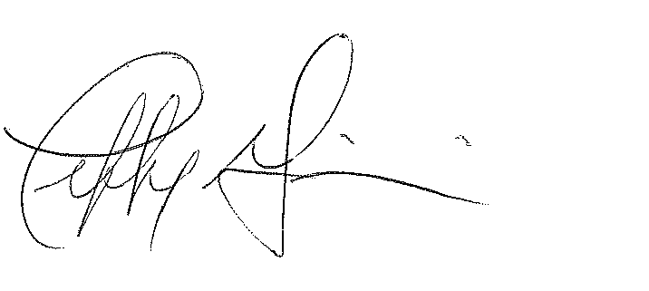

Jeffrey R. Gaudiosi, Esq.

Executive Secretary

cc: Service List

1. The Combined Public Benefits Charge is comprised of four individual rates: the Conservation and Load Management Program Charge, Renewable Energy Investment Charge, Conservation Adjustment Mechanism, and Systems Benefit Charge.